III. Sensible Approaches to Alternative Teacher Licensure. Given the fact that Ohio allows and encourages both traditional and alternative paths to teacher licensure, we will advocate for:  - Alternative licensure requirements for non-profit institutions to offer programs that do not sacrifice quality in the interest of speed  - Simple and consistent administrative language about program approval requirements to verify that alternatively licensed teachers will be highly qualified, with the necessary knowledge and skills to begin teaching  - Establishment of common metrics to provide accountability and allow inquiry into the efficacy of teacher education pathways (e.g. admission standards, exit requirements, performance evaluations)  - Mentoring programs for alternatively licensed teachers supporting growth along the teaching continuum | IV. Stability of ODE Policies – Licensing, P-12 Curriculum and Instruction. P-12 policies sometimes have unintended consequences on teacher preparation programs. We will advocate for:  - Policies that enhance the professionalization of teaching through the recognition and reward of teachers as knowledgeable professionals with specialized knowledge and skills  - Modification of established curriculum models, student assessments, and teacher evaluation in a gradual fashion allowing sufficient time for implementation  - Alignment of K-12 curriculum with Specialized Professional Association (SPA) content standards  - Awareness of how P-12 policies intersect with teacher preparation issues (e.g. licensure bands impacts licensure standards, licensure tests, SPA approval; school year start date impacts student teaching semester)  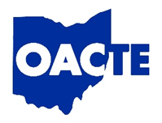 | 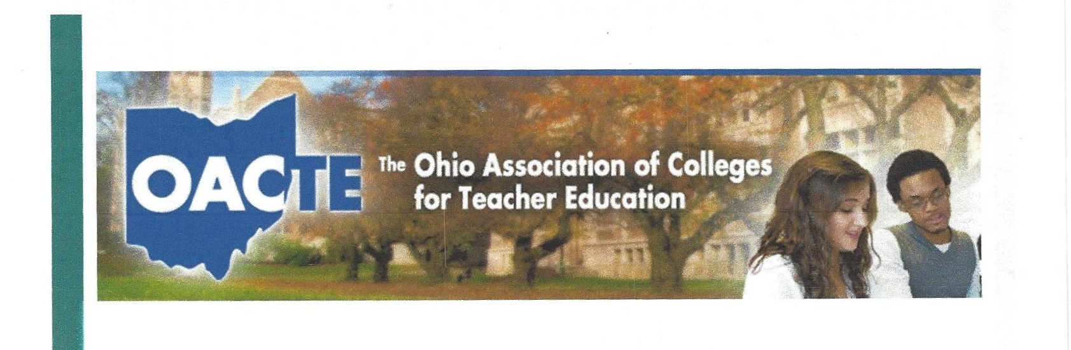  THE OHIO ASSOCIATION OF COLLEGES FOR TEACHER EDUCATION  OACTE Legislative Platform  OACTE Advocacy Committee
As the umbrella organization for Ohio teacher preparation programs, the Ohio Association of Colleges for Teacher Education (OACTE) proposes the following guiding principles established collaboratively and approved by OACTE membership. The principles should be used to inform advocacy efforts supporting and advancing legislation to promote high quality teacher preparation and ensure well-prepared teachers for all Ohio children.  I. OACTE Input on Educator Preparation Program Requirements and Policies. To acknowledge the expertise of our teacher education institutions, we will advocate for:  - Creation of a subcommittee of the Educator Standards Board for traditional and alternative teacher preparation standards  - A transparent process for soliciting knowledgeable, engaged representation providing a healthy balance of perspectives by region, public/private institutions, gender and race  - Support for feedback channels providing outward communication of proposed legislative or administrative policy changes and | - gathering feedback on the impact of such changes  - Proposing new requirements so that all teacher preparation requirements are viewed as a coherent whole rather than in piecemeal fashion, avoiding wherever possible proliferation of highly-specific requirements that prohibit innovation or cause deterioration of existing models of excellence  - Introduction of new requirements on a reasonable timeline to allow for proper implementation  II. Policies that Foster Partnerships between EPPs and P-12 Districts. Policies can support or inhibit EPPs’ abilities to partner with schools. We will advocate for:  - Policies and systems that promote data systems and data sharing platforms that are mutually beneficial for P-12 districts (e.g. tracking P-12 graduates into higher education, EPP completers into P-12 employment, student growth measures to analyze impact of licensure candidates in clinical experiences) | - Establishment of universal instruments and processes for requesting field experiences  - Establishment of policies that increase the appeal for K-12 professionals to work with EPP candidates (e.g. roll back Ohio ethics rules preventing payment/compensation to mentor teachers, build incentives into OTES for working with student teachers, reducing concerns about student teachers having a negative impact on student growth measures, paid internships to develop employment pipeline)  - Support and development of alternative strategies to incentivize school districts to host teacher candidates (mentoring/tutoring programs, professional development, credit banking)  - Alignment of support and assessment processes across EPP and P-12 to take advantage of a developmental model for teacher preparation (e.g. alignment between edTPA/RESA)

